**OUTPUT**

**Git Bash:**

**Creating .log file and log folder**

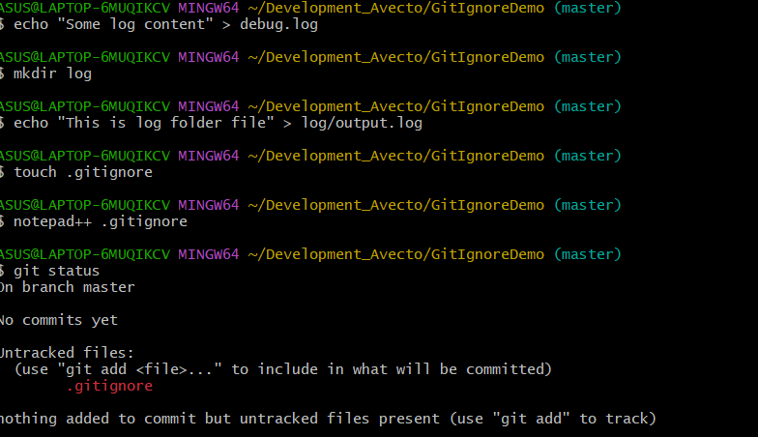

**Notepad++:**

